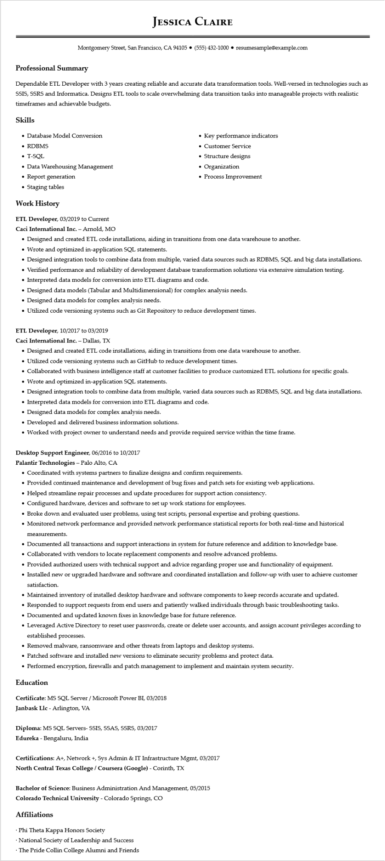
JESSICA CLAIRE
Montgomery Street, San Francisco, CA 94105 ⚫ (555) 432-1000⚫ resumesample@example.com
Professional Summary
Dependable ETL Developer with 3 years creating reliable and accurate data transformation tools. Well-versed in technologies such as SSIS, SSRS and Informatica. Designs ETL tools to scale overwhelming data transition tasks into manageable projects with realistic timeframes and achievable budgets.
Skills
• Database Model Conversion
• RDBMS
• T-SQL
• Data Warehousing Management
• Report generation
• Staging tables
Work History
ETL Developer, 03/2019 to Current
Caci International Inc. - Arnold, MO
• Key performance indicators
• Customer Service
• Structure designs
• Organization
• Process Improvement
• Designed and created ETL code installations, aiding in transitions from one data warehouse to another.
• Wrote and optimized in-application SQL statements.
• Designed integration tools to combine data from multiple, varied data sources such as RDBMS, SQL and big data installations.
• Verified performance and reliability of development database transformation solutions via extensive simulation testing.
• Interpreted data models for conversion into ETL diagrams and code.
• Designed data models (Tabular and Multidimensional) for complex analysis needs.
• Designed data models for complex analysis needs.
• Utilized code versioning systems such as Git Repository to reduce development times.
ETL Developer, 10/2017 to 03/2019
Caci International Inc. - Dallas, TX
• Designed and created ETL code installations, aiding in transitions from one data warehouse to another.
• Utilized code versioning systems such as GitHub to reduce development times.
• Collaborated with business intelligence staff at customer facilities to produce customized ETL solutions for specific goals.
• Wrote and optimized in-application SQL statements.
• Designed integration tools to combine data from multiple, varied data sources such as RDBMS, SQL and big data installations.
• Interpreted data models for conversion into ETL diagrams and code.
• Designed data models for complex analysis needs.
• Developed and delivered business information solutions.
• Worked with project owner to understand needs and provide required service within the time frame.
Desktop Support Engineer, 06/2016 to 10/2017
Palantir Technologies - Palo Alto, CA
• Coordinated with systems partners to finalize designs and confirm requirements.
• Provided continued maintenance and development of bug fixes and patch sets for existing web applications.
• Helped streamline repair processes and update procedures for support action consistency.
• Configured hardware, devices and software to set up work stations for employees.
• Broke down and evaluated user problems, using test scripts, personal expertise and probing questions.
• Monitored network performance and provided network performance statistical reports for both real-time and historical measurements.
• Documented all transactions and support interactions in system for future reference and addition to knowledge base.
• Collaborated with vendors to locate replacement components and resolve advanced problems.
• Provided authorized users with technical support and advice regarding proper use and functionality of equipment.
• Installed new or upgraded hardware and software and coordinated installation and follow-up with user to achieve customer satisfaction.
• Maintained inventory of installed desktop hardware and software components to keep records accurate and updated.
• Responded to support requests from end users and patiently walked individuals through basic troubleshooting tasks.
• Documented and updated known fixes in knowledge base for future reference.
• Leveraged Active Directory to reset user passwords, create or delete user accounts, and assign account privileges according to established processes.
• Removed malware, ransomware and other threats from laptops and desktop systems.
• Patched software and installed new versions to eliminate security problems and protect data.
• Performed encryption, firewalls and patch management to implement and maintain system security.
Education
Certificate: MS SQL Server / Microsoft Power BI, 03/2018
Janbask Llc - Arlington, VA
Diploma: MS SQL Servers- SSIS, SSAS, SSRS, 03/2017
Edureka - Bengaluru, India
Certifications: A+, Network +, Sys Admin & IT Infrastructure Mgmt, 03/2017
North Central Texas College / Coursera (Google) - Corinth, TX
Bachelor of Science: Business Administration And Management, 05/2015
Colorado Technical University - Colorado Springs, CO
Affiliations
Phi Theta Kappa Honors Society
• National Society of Leadership and Success
• The Pride Collin College Alumni and Friends

